Name :Yashwant Singh Rathore

Topic :Agile and Jira(created Account on Jira)

What is Agile?

Agile is an iterative approach to project management and software development that helps teams deliver value to their customers faster and with fewer headaches. Instead of betting everything on a "big bang" launch, an agile team delivers work in small, but consumable, increments. Requirements, plans, and results are evaluated continuously so teams have a natural mechanism for responding to change quickly.

## Why choose agile?

Teams choose agile so they can respond to changes in the marketplace or feedback from customers quickly without derailing a year's worth of plans. "Just enough" planning and shipping in small, frequent increments lets your team gather feedback on each change and integrate it into future plans at minimal cost.

But it's not just a numbers game—first and foremost, it's about people. As described by the Agile Manifesto, authentic human interactions are more important than rigid processes. Collaborating with customers and teammates is more important than predefined arrangements. And delivering a working solution to the customer's problem is more important than hyper-detailed documentation.

Jira

Jira is a software application developed by the Australian software company Atlassian that allows teams to track issues, manage projects, and automate workflows.

## Different Uses of Jira

Originally designed as a bug and issue tracker, Jira serves as a powerful work management tool for various use cases like:

* Requirement and Test case Management – to manage manual and automated tests
* Agile Teams – JIRA software provides scrum and Kanban boards for teams practicing agile methodologies.
* Project Management – JIRA software can be configured to fit any type of project right from onset, through execution, to wrap up.
* Software Development – for developing better software, faster by incorporating Atlassian tools.
* DevOps – Atlassian open DevOps helps teams ship better software, stressing on best practices.
* Product Management – JIRA help design detailed roadmaps, handle dependencies, and share plans and progresses.
* Task Management –JIRA makes it easy to create tasks to work on, with details, due dates and reminders.

**Created Account on Jira**

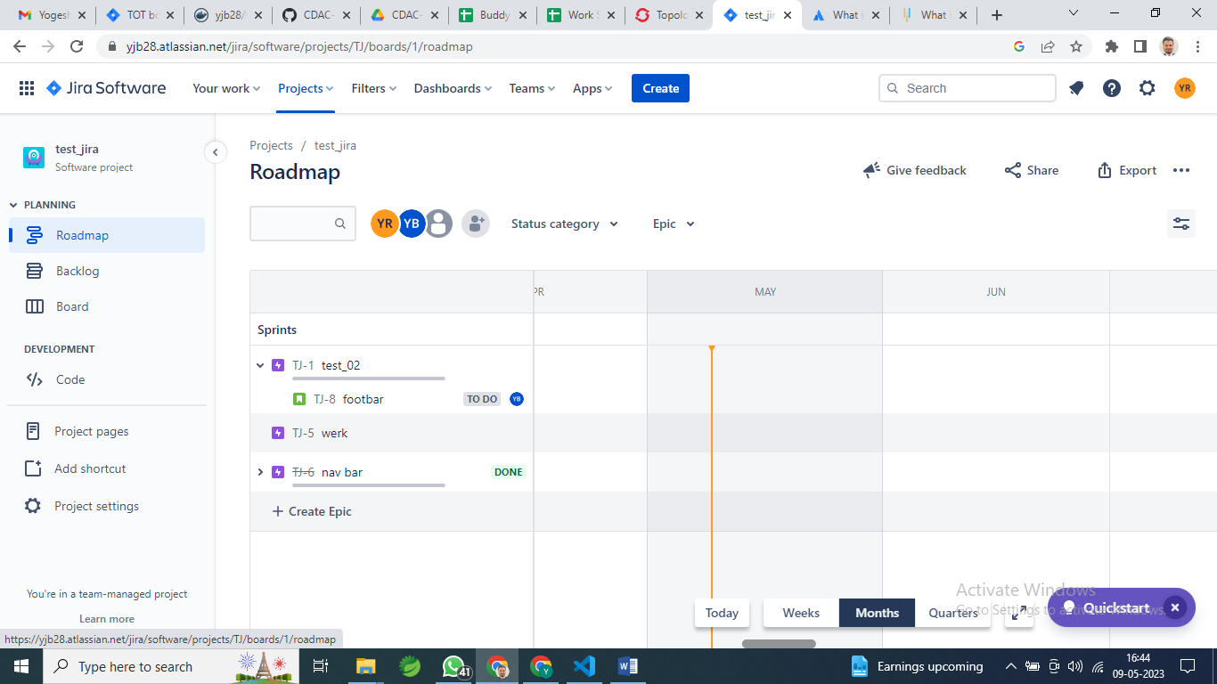

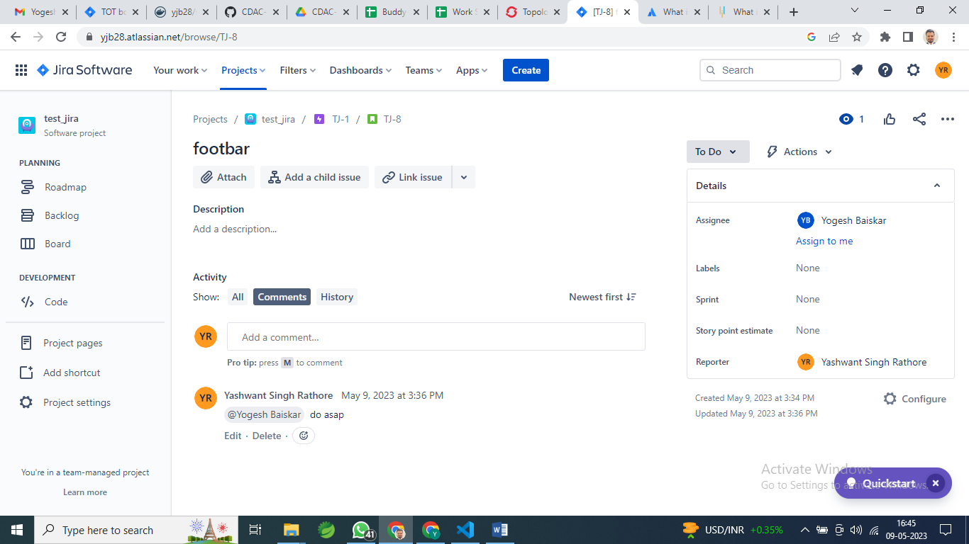

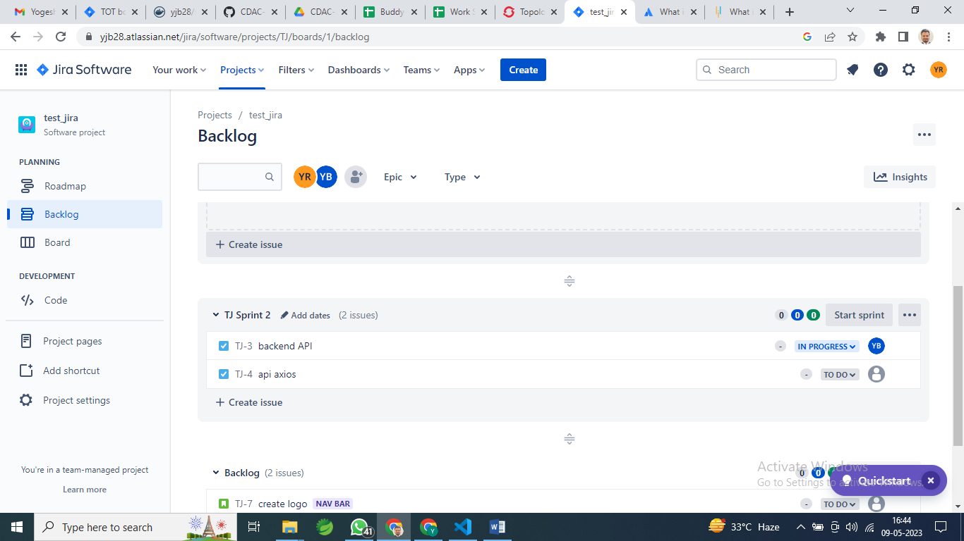

**Assign work**

